**DAILY ONLINE ACTIVITIES SUMMARY**

|  |  |  |  |  |  |  |  |  |
| --- | --- | --- | --- | --- | --- | --- | --- | --- |
| **Date:** | **30-05-2020** | | | | | **Name:** | **Apeksha Rane** | |
| **Sem & Sec** | **A** | | | | | **USN:** | **4AL17CS010** | |
| **Online Test Summary** | | | | | | | | |
| **Subject** | | **Python Application Programming.** | | | | | | |
| **Max. Marks** | | **30** | | **Score** | | | **08** | |
| **Certification Course Summary** | | | | | | | | |
| **Course** | **INTRODUCTION TO CLOUD** | | | | | | | |
| **Certificate Provider** | | | COGNITIVE  CLASS IBM. | | **Duration** | | | 6hours |
| **Coding Challenges** | | | | | | | | |
| **Problem Statement:**1. Python program to read a number and print the pattern.  2. write a java program to Count number of trailing zeros in product of array. | | | | | | | | |
| **Status: Done** | | | | | | | | |
| **Uploaded the report in Github** | | | | | **YES** | | | |
| **If yes Repository name** | | | | | <https://github.com/Apeksha12appu/19-5-2020-online-coding-activity> | | | |
| **Uploaded the report in slack** | | | | | **YES** | | | |

Online Test Details:

Subject:- **Python Application Programming.**

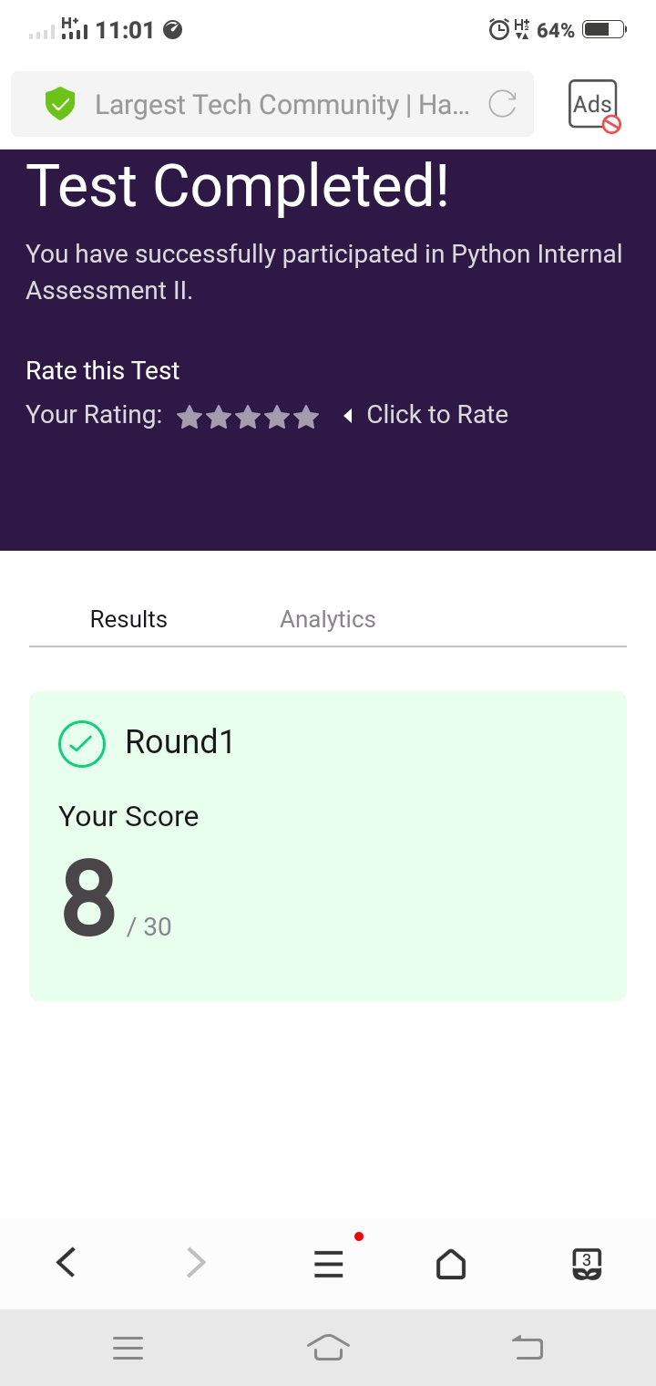

Certification Course Details:

**Introduction to Cloud:**

Today I have studied  **Cloud Computing Service and Deployment Models** **:**

* Introduction and Objectives.
* Overview of service Models.
* Infrastructure as a Service.
* Platform as a Service.
* Software as a service.
* Public cloud.
* Private Cloud.
* Hybrid Cloud.

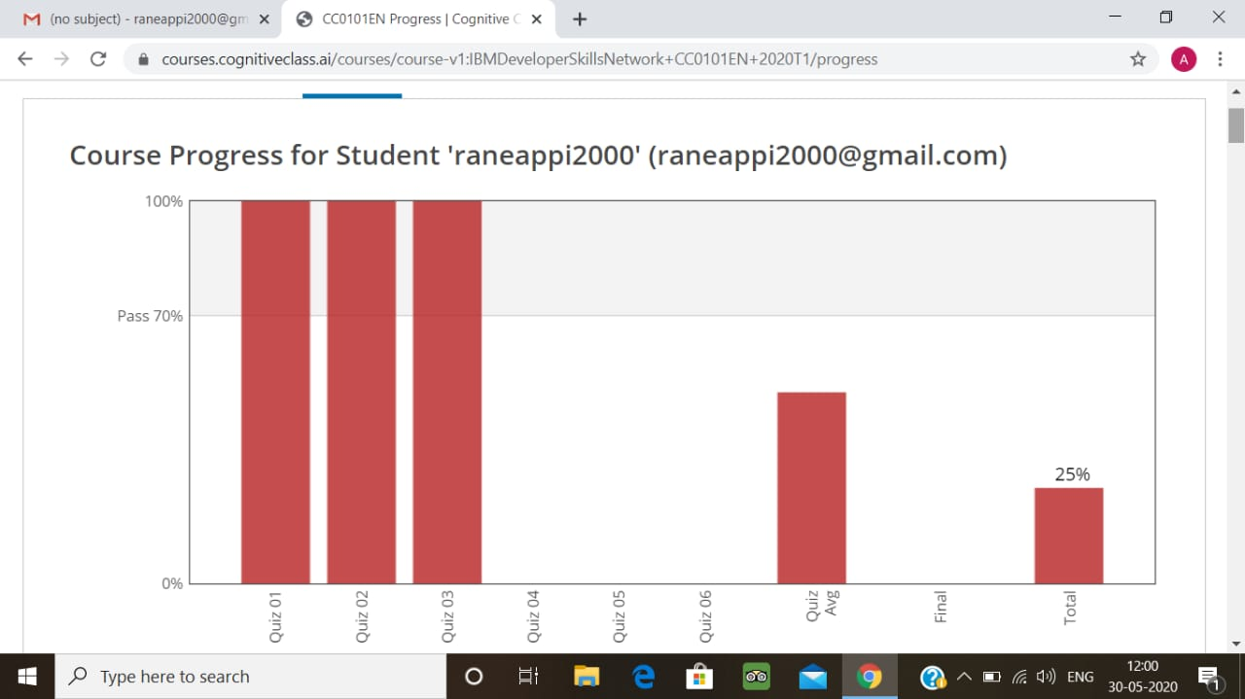

Coding Challenges Details:

1. Python program to read a number and print the pattern

rows = int(input("Enter the number of rows "))

for i in range(rows + 1, 0, -1):

for j in range(0, i - 1):

print("*", end=' ')

print(" ")

**output:**

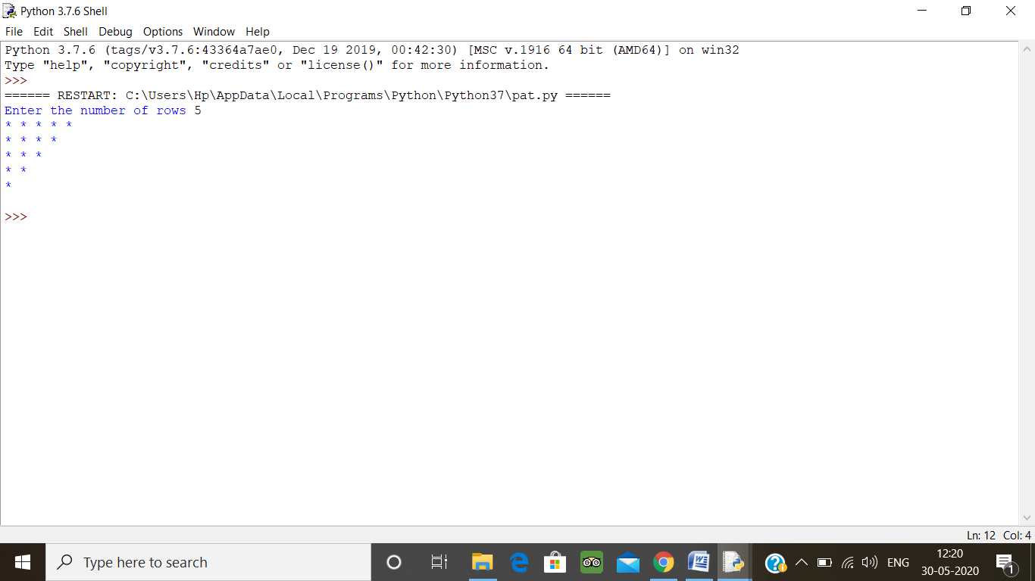

2. write a java program to Count number of trailing zeros in product of array

A simple solution is simply multiply and count trailing 0s in product. This solution may cause integer overflow. A better solution is based on the fact that zeros are formed by a combination of 2 and 5. Hence the number of zeros will depend on the number of pairs of 2’s and 5’s that can be formed.  
Ex.: 8 * 3 * 5 * 23 * 17 * 25 * 4 * 11  
23 * 31 * 51 * 231 * 171 * 52 * 22 * 111  
In this example there are 5 twos and 3 fives. Hence, we shall be able to form only 3 pairs of (2*5). Hence will be 3 Zeros in the product.

import java.util.*;

import java.lang.*;

public class Main

{

public static int countZeroso(int[] a, int n)

{

int count2 = 0, count5 = 0;

for (int i = 0; i < n; i++)

{

while (a[i] % 2 == 0)

{

a[i] = a[i] / 2;

count2++;

}

while (a[i] % 5 == 0)

{

a[i] = a[i] / 5;

count5++;

}

}

return (count2 < count5) ? count2 : count5;

}

public static void main(String argc[])

{

int[] a = new int[]{ 10, 100, 20, 30,

50, 91, 12, 80 };

int n = 8;

System.out.println(countZeroso(a, n));

}

}

**Output:**

